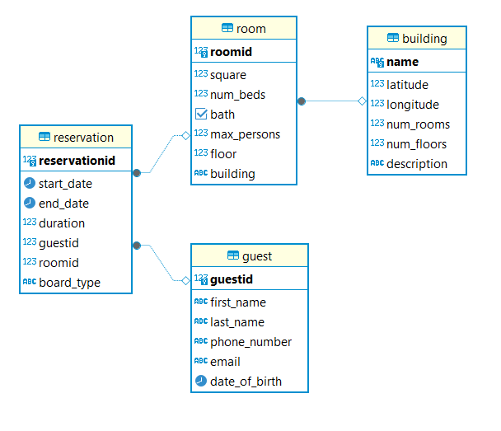Picture 1. Screenshot of database diagram.

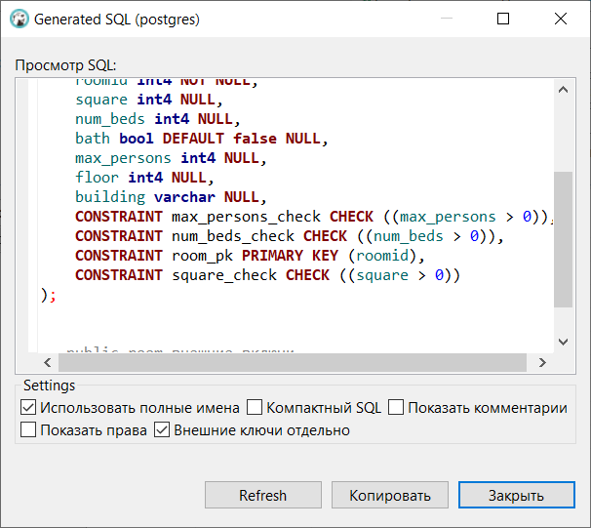Picture 2. Screenshot of 3 check constraints.

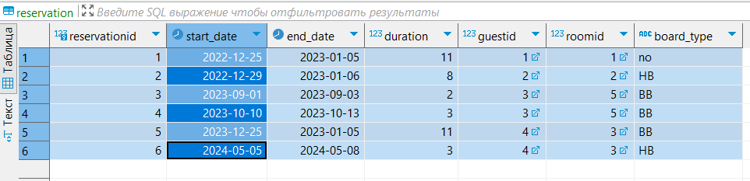Picture 3. Screenshot of reservation table data.